Recipe Management Application (React+Django)

**Table of Contents**

1. Project Overview
2. Tech Stack
3. Architecture
4. Deployment
   * Frontend Deployment
   * Backend Deployment
5. Bonus Requirements
   * CloudFront for CDN
   * Custom VPC
6. Presentation of Work
   * Gifs and Screenshots
7. Conclusion

**Project Overview**

The project is a Recipe Management Application inspired by Kangcook. It allows users to store and manage their favourite recipes. The application includes a frontend built with React.js and a backend built with Django, deployed on AWS.

**Tech Stack**

* **Frontend:** React.js
* **Backend:** Django
* **Deployment:** AWS S3, AWS EC2
* **Additional Services:** Custom VPC, AWS CloudFront

**Architecture Overview**

The application is structured with a clear separation between the frontend and backend. The frontend is hosted on AWS S3 and served via AWS CloudFront for better performance and security. The backend is hosted on an EC2 instance within a custom VPC, ensuring secure and controlled access.

**Deployment**

**Frontend Deployment**

1. **Build React Application:**

npm run build

1. **Create an S3 Bucket:**
   * Go to the S3 Dashboard and create a new bucket.
   * Upload the build files to the bucket.
   * Configure the bucket for static website hosting.
   * Permit public access

**Backend Deployment**

**1. Launch EC2 Instance**

1. **Login to AWS Management Console:**
   * Navigate to the EC2 Dashboard.
2. **Launch an Instance:**
   * Click on "Launch Instance."
   * Choose an Amazon Machine Image (AMI) (e.g., Amazon Linux 2).
   * Select an instance type (e.g., t2.micro).
   * Configure instance details (e.g., default VPC, subnet).
   * Configure the security group to allow HTTP (port 80), HTTPS (port 443), and SSH (port 22).
   * Review and launch the instance.
3. **Create or Select a Key Pair:**
   * Choose an existing key pair or create a new one to access the instance.

**2. SSH into EC2 Instance**

1. **Connect to Your Instance:**
   * Open your terminal or command prompt.
   * Use the following command to SSH into your instance:

ssh -i /path/to/your-key-pair.pem ec2-user@your-ec2-public-ip

**3. Update and Install Dependencies**

1. **Update the Package List:**

sudo yum update -y

1. **Install Required Packages:**

sudo yum install git python3 python3-pip

1. **Upgrade Pip:**

sudo pip3 install --upgrade pip

**4. Transfer Files**

**1. Clone the Repo**

git clone your_repo_url

**2. Create and Activate env**

**3. Install dependencies**

Pip install -r requirements.txt

**4. Install and Configure Gunicorn**

1. **Install Gunicorn:**

sudo pip3 install gunicorn

1. **Run Gunicorn:**

gunicorn --bind 0.0.0.0:8000 PROJECT_NAME.wsgi --daemon

**Bonus Requirements**

**CloudFront for CDN**

**Step-by-Step Guide**

1. **Create a CloudFront Distribution:**
   * Go to the CloudFront service in the AWS Management Console.
   * Click "Create Distribution."
   * Select "Web" as the delivery method.
2. **Configure Origin Settings:**
   * For Origin Domain Name, select your S3 bucket where the frontend is hosted.
   * Keep the default settings for the rest of the fields and click "Create Distribution."

**Custom VPC**

**Step-by-Step Guide**

1. **Create a VPC:**
   * Go to the VPC Dashboard in the AWS Management Console.
   * Click "Create VPC."
   * Provide a name for your VPC, specify an IPv4 CIDR block, and click "Create."
2. **Create Subnets:**
   * Create a private subnet for the EC2 instance.
   * Ensure each subnet has an appropriate IPv4 CIDR block.

# Presentation of Work

**Live Website:** <http://recipe-frontend-bucket.s3-website.us-east-2.amazonaws.com/>

**GIF:** <https://github.com/user-attachments/assets/ec44d892-d044-4ac5-9b24-3e0b3d93eb59>



**Screenshots:**

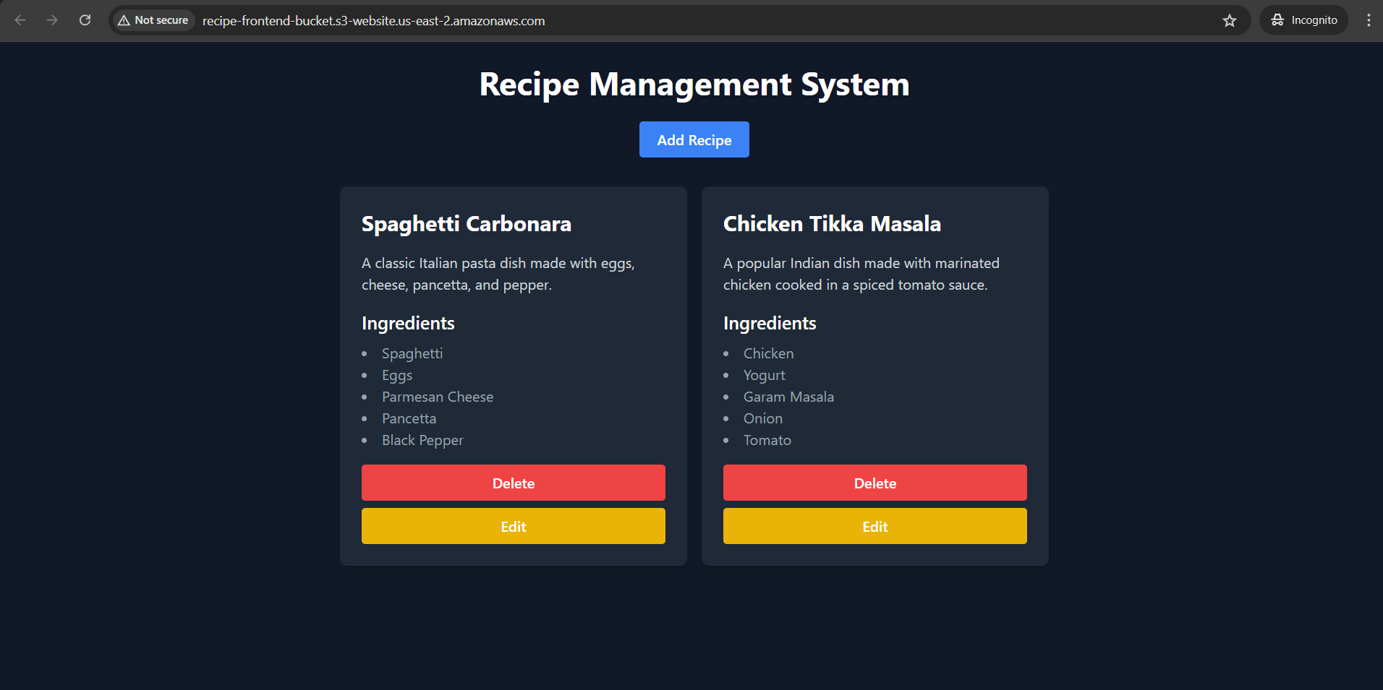

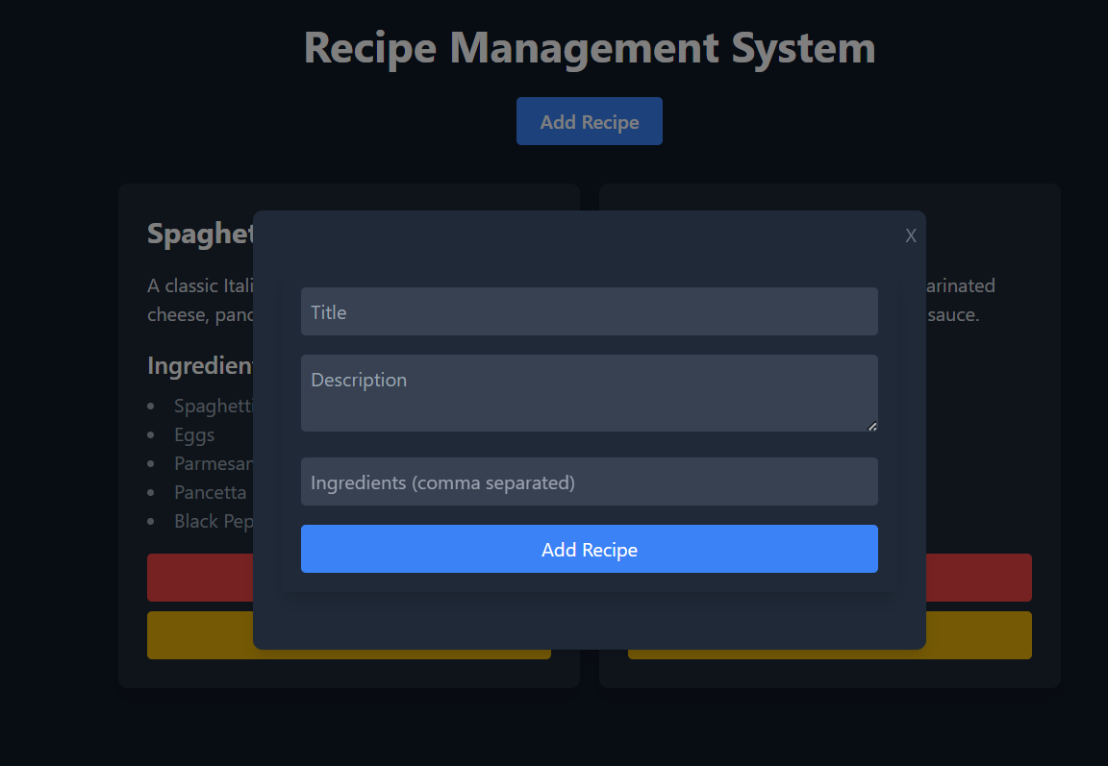

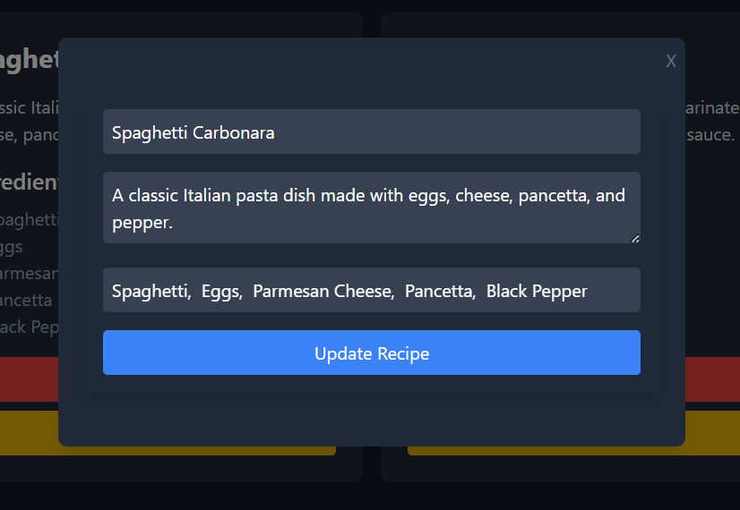

**Conclusion**

This project demonstrates the development and deployment of a full-stack Recipe Management Application using modern web technologies and AWS services. The frontend, built with React.js, is hosted on S3 and served via CloudFront for optimized performance. The backend, developed with Django, is securely hosted on an EC2 instance within a custom VPC, leveraging Gunicorn.